Subject: Student Exchange Programme 2023-24: Main Round Application



GET READY! Embark on an Adventurous Journey!
Main Round Application
for Student Exchange Programme 2023-24

Student Exchange Programme (SEP) offers exchange opportunities in over 45 destinations around the world. The Main Round Application of SEP for exchange programmes in 2023-24 is opening from 5 December 2022 to 25 January 2023. Don’t miss the chance!

Four Wise Steps for an Application

STEP 1: Check the application details on Global Engagement Office (GEO) website at https://www.cityu.edu.hk/geo/StudentExchange/.

STEP 2: Attend one of the Pre-application Information Sessions to learn about the exchange options, application requirements and funding resources.

STEP 3: Consult your academic advisor or exchange coordinator on your study plan.

STEP 4: Submit your application on AIMS via the "Outbound Student Exchange Application" section under "Student Services" during 5 December 2022 to 25 January 2023.

Listen to our student, Vikki, to learn what SEP is about: https://cityuhk-lms.ap.panopto.com/Panopto/Pages/Viewer.aspx?id=b530a566-e1d8-493d-9041-addc0077adac

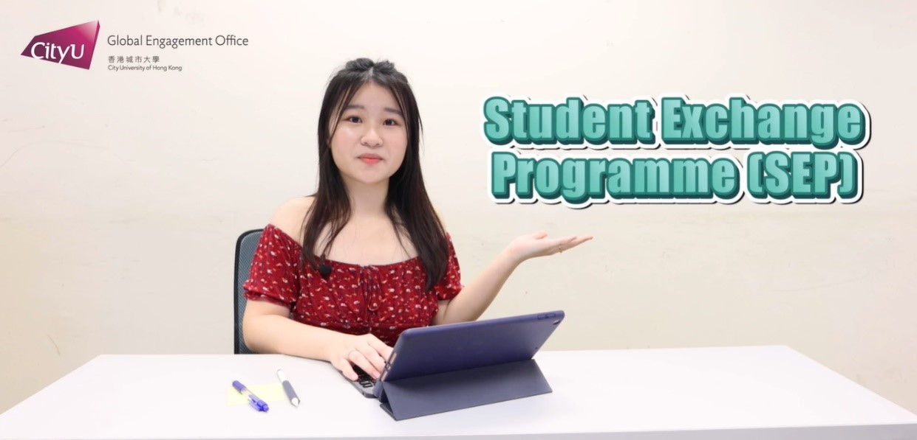

DREAM BIG; START SMALL; ACT NOW!

